## Exercise 5 – Seasonal Adjustment

Run *.\data\cr\CR Regional IPC.spc*. Examine the seasonality of the series. Should it be seasonally adjusted?

There are no peaks at seasonal frequencies in the spectrum of the original series.

The QS of the original series has p < 0.01, but the QS on the shortened series does not (p = 0.44).

M7 = 0.94 and D8F = 10.1, which both indicate a seasonal series.

The ARIMA model selected is (1 2 1)(0 1 1). When the series is run with (1 2 1) + seasonal, the seasonal regressors are significant (p = 0.00).

The QS, M7, D8F, and seasonal regressors are all calculated over the full span and all indicate a (mildly) seasonal series. The spectrum and QS of the shortened series are calculated on the last 8 years and do not find seasonality. We can run the series with a span start of 2011.1 (roughly 8 years), and we find that the seasonal regressors are no longer significant (p = 0.13), D8F = 6.4 <7, and M7 = 0.98. The series seems to be becoming less seasonal over time.

Note also that seasonal adjustment changes the adjustment very little; the largest seasonal factors are 1.005.

Create a spec file for .\data\retail\fuel dealers.dat. On the ARIMA Model tab, select the airline model. Run the spec file.

1. Describe the spectrum of the original series. There are visually significant peaks at S1, S2, and S5. S3 and S4 are also peaks, but they are not visually significant.
2. Look at the spectrum of the seasonally adjusted series, the irregular, and the residuals. Is there evidence of residual seasonality or residual calendar effects? There are no seasonal peaks in the spectrum of the seasonally adjusted series or the irregular, so there is no residual seasonality. There are no trading day peaks in any spectra, so no residual calendar effects. There is a visually significant seasonal peak at S5 in the spectrum of the residuals and the seasonal peak at S1 is almost significant – 5.5 stars – which may indicate problems modeling the seasonal pattern.
3. When you created this spec file, the seasonal filter was chosen based on the global moving seasonality ratio. What was the GMSR (I/S ratio) for this series? What seasonal filter was chosen? The GMSR (I/S Ratio) is 3.42, and a 3x5 filter was selected.
4. Look at the sliding spans diagnostics. Is this adjustment acceptably stable? Why or why not? There are 26% months with failing seasonal factors and 22% of months have a failing month-to-month change. This is not acceptably stable, since we would like % failing SF to be below 15% and we really want it below 25%. The month to month changes are okay, as we’d like these to be below 40%.
5. Look in the output file for the history tables. Which months have the largest revisions?

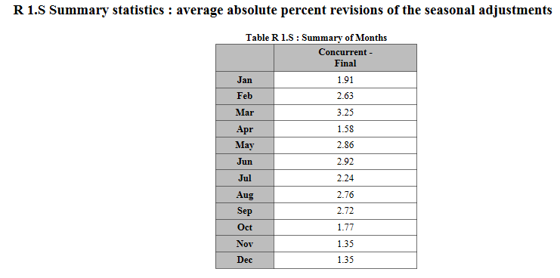

The highest revisions are in March.

1. a) Look at the graph of the Seasonal Factors and SI Ratios by Month, or at Table D9. Which months have the most replaced SI ratios? February and March both have 8 months with a replaced SI ratio. January and December both have 7 replaced values.

b) Raise the sigma limits to (1.8 2.8) and run the spec with the output name *Fuel dealers SL*. Are there fewer replaced SI ratios in the months identified in 6a)? With the higher limits, January has 4 replacements (down 3), February has 7 (down 1), March has 7 (down 1), and December has 6 (down 1).

Replace the x11{} spec with seats{} and run the spec file as *Fuel dealers seats.*

Set the model span to start in 2004.1 and run the spec file as *Fuel dealers seats 2*.

1. Compare the regARIMA models from the *Fuel dealers seats* and *Fuel dealers seats 2*. Which model has better model diagnostics? The full span model has 10 failing LBQ, including lags 12 and 24. It has 3 lags with a significant ACF (but they are at 5, 11, and 23, which are not considered important lags) and a visually significant peak at S5 in the residuals – this is not a peak we generally worry about when the other seasonal frequencies are not peaks, but S1 is almost a visually significant peak (5.5 stars). With the shorter model span, there are no LBQ or ACF failures and no seasonal or trading day peaks in the spectrum of the residuals. But forecasts are a little worse for the short model span series.
2. Compare the sliding spans diagnostics and the revisions from the four adjustments. Which adjustment has the greatest stability?

Sliding span results are a little better for fd.seats2 then for either of the x11 adjustments. They look best for *Fuel dealers seats*, but the span length is 102 for the other three models and 198 for *Fuel dealers seats*, so this comparison is problematic.

We can compare the average SA and MM revisions in *Fuel dealers x11*, *Fuel dealers x11sl*, and *Fuel dealers seats* because they have the same start date (2000.1). *Fuel dealers seats* has the largest revision in the seasonal adjustment (2.6, compared to 2.3 and 2.2 for the x11 adjustments) but the smallest revision in the month-to-month change (1.67, compared to 1.83 and 1.76).

We can set the history start date to 2009.1 for all four adjustments, and then *Fuel dealers seats2* has the lowest revisions (2.78 SA and 1.63 MM) while *Fuel dealers seats* has the worst (3.56 SA and 2.05 MM), with the X-11 adjustments in the middle (*Fuel dealers x11*: 3.16 SA and 1.92 MM *Fuel dealers x11sl*: 3.03 SA and 1.77 MM).

1. Use X-13-Graph to create a graph comparing the four seasonal adjustments.
   1. Press the ‘Add series’ button. Select the four *Fuel dealer* series and press ‘Open’ to add them to the list of series.
   2. On the main X-13-Graph page, find the series in the top left list box. Select two of them using the Control button.
   3. ‘Overlay Graphs to Compare Two Models’ should already be selected from the Graph Types drop down box. Select ‘Seasonally Adjusted Series’ from both the top and bottom Graph list boxes. Press ‘Graph’ to create the graph.
   4. Select ‘Seasonal Factor Overlay Graphs’. Select Seasonal Factors from the top and bottom list boxes. Press ‘Graph’.

How similar are the adjustments? Where do you see the biggest differences? The two x11 adjustments are very similar and the two seats adjustments are very similar. The largest differences are between the x11 and the seats adjustments.